Sphere Equator
# Source: AI Source: Provided by: [Data Path: Persons Table -> ID Column: 1, Name_En Column: Motasem Essam] -> From: [ChatGPT] on [7/25/2026]
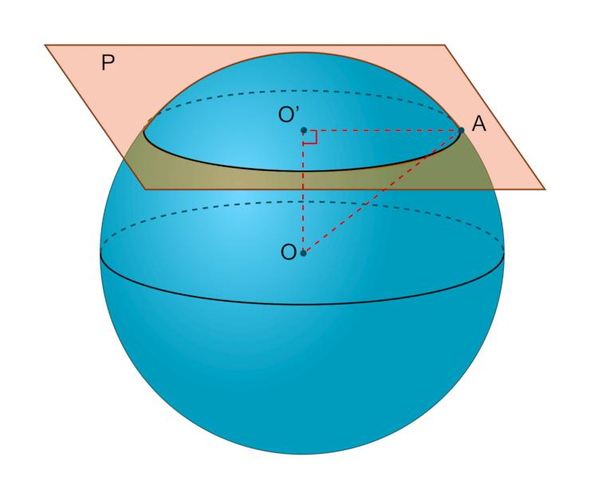
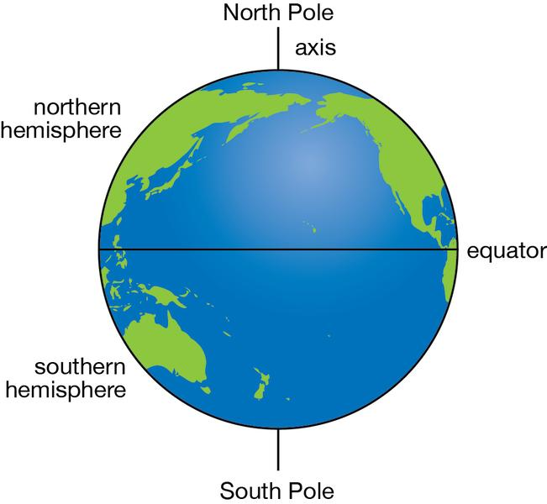
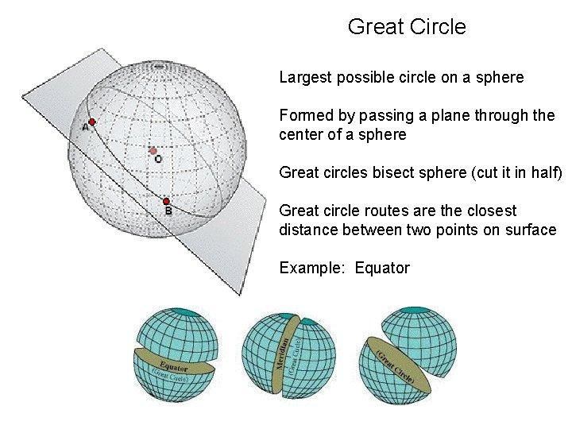

Definition
# Source: AI Source: Provided by: [Data Path: Persons Table -> ID Column: 1, Name_En Column: Motasem Essam] -> From: [ChatGPT] on [7/25/2026]
The sphere equator is the great circle formed by the intersection of a sphere's surface with a plane passing through its center and perpendicular to a chosen polar axis.
For Earth, the equator is an imaginary circle halfway between the North Pole and the South Pole. It divides Earth into the Northern Hemisphere and the Southern Hemisphere.
A perfect mathematical sphere does not have a unique equator unless an axis or orientation is chosen. Once a polar axis is specified, the equator is defined relative to that axis.

Simple Definition
# Source: AI Source: Provided by: [Data Path: Persons Table -> ID Column: 1, Name_En Column: Motasem Essam] -> From: [ChatGPT] on [7/25/2026]
The sphere equator is the circular line around a sphere's widest middle region, halfway between its two chosen poles.

Geometric Representation
# Source: AI Source: Provided by: [Data Path: Persons Table -> ID Column: 1, Name_En Column: Motasem Essam] -> From: [ChatGPT] on [7/25/2026]
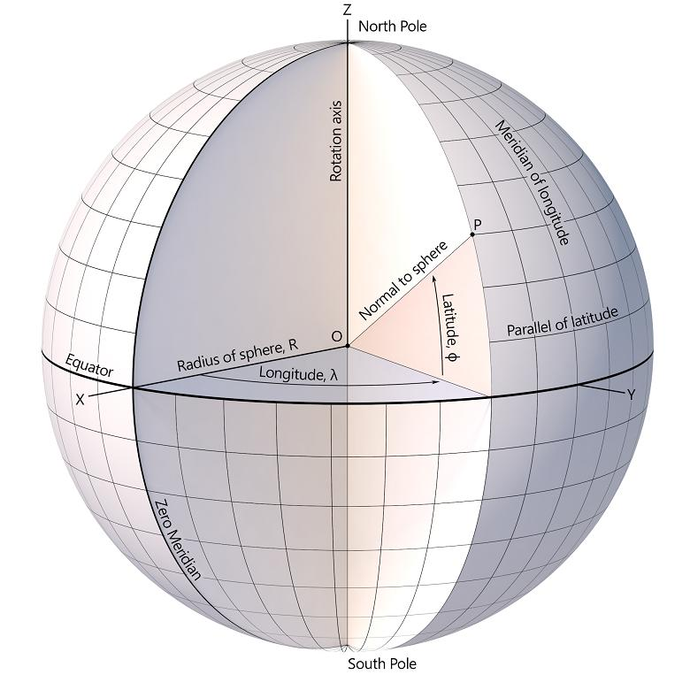
The sphere equator has these main components:
- Equatorial circle: The circle on the sphere's surface.
- Equatorial plane: The plane that passes through the sphere's center and contains the equatorial circle.
- Sphere center: The center of the sphere, lying in the equatorial plane.
- Polar axis: The selected axis perpendicular to the equatorial plane.
- Poles: The two points where the polar axis meets the sphere's surface.
The equatorial plane cuts a perfect sphere into two equal hemispheres.

Mathematical Properties
# Source: AI Source: Provided by: [Data Path: Persons Table -> ID Column: 1, Name_En Column: Motasem Essam] -> From: [ChatGPT] on [7/25/2026]
The sphere equator is a great circle because its plane passes through the center of the sphere. Therefore, its radius is equal to the sphere's radius.
Equatorial radius
$$r_{e}=R$$
Equatorial diameter
$$D_{e}=2R$$
Equatorial circumference
$$C_{e}=2πR$$
Equatorial disk area
$$A_{e}=πR^{2}$$
Where:
- $R$ = sphere radius.
- $r_{e}$ = radius of the equatorial circle.
- $D_{e}$ = diameter of the equatorial circle.
- $C_{e}$ = circumference of the equatorial circle.
- $A_{e}$ = area of the flat circular disk bounded by the equator.
Important: The equatorial disk area is not the curved surface area of the sphere.

Key Characteristics
# Source: AI Source: Provided by: [Data Path: Persons Table -> ID Column: 1, Name_En Column: Motasem Essam] -> From: [ChatGPT] on [7/25/2026]
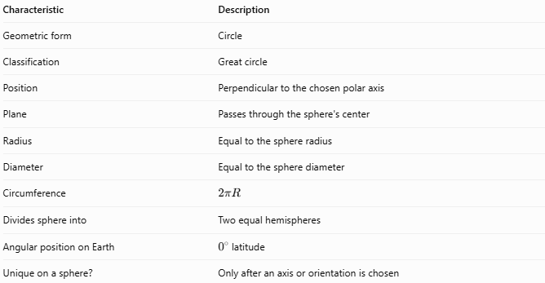
Characteristic | Description
Geometric form | Circle
Classification | Great circle
Position | Perpendicular to the chosen polar axis
Plane | Passes through the sphere's center
Radius | Equal to the sphere radius
Diameter | Equal to the sphere diameter
Circumference | $$2πR$$
Divides sphere into | Two equal hemispheres
Angular position on Earth | \(0^\circ\) latitude
Unique on a sphere? | Only after an axis or orientation is chosen

Worked Examples
# Source: AI Source: Provided by: [Data Path: Persons Table -> ID Column: 1, Name_En Column: Motasem Essam] -> From: [ChatGPT] on [7/25/2026]
Example 1 — Calculate the Equatorial Circumference
Given: A sphere has a radius of $7\text{ cm}$.
The equator is a great circle, so:
$$C_{e}=2πR$$
$$C_{e}=2π\left(7\right)=14π$$
$$\boxed{C_{e}≈43.98\text{ cm}}$$
Answer: The equatorial circumference is approximately $43.98\text{ cm}$.
Example 2 — Calculate the Equatorial Diameter
Given: The sphere radius is $12\text{ m}$.
$$D_{e}=2R=2\left(12\right)$$
$$\boxed{D_{e}=24\text{ m}}$$
Answer: The equatorial diameter is $24\text{ m}$.
Example 3 — Find the Equatorial Disk Area
Given: The sphere radius is $5\text{ cm}$.
$$A_{e}=πR^{2}$$
$$A_{e}=π{\left(5\right)}^{2}=25π$$
$$\boxed{A_{e}≈78.54{\text{ cm}}^{2}}$$
Answer: The equatorial disk area is approximately $78.54{\text{ cm}}^{2}$.

Sphere Equator vs. Related Concepts
# Source: AI Source: Provided by: [Data Path: Persons Table -> ID Column: 1, Name_En Column: Motasem Essam] -> From: [ChatGPT] on [7/25/2026]
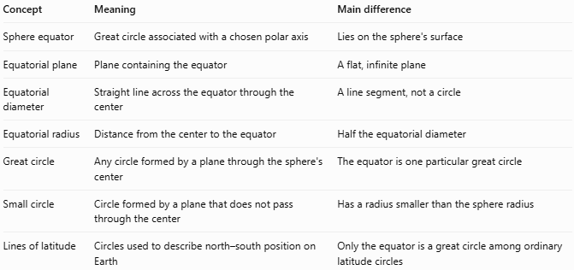
Concept | Meaning | Main difference
Sphere equator | Great circle associated with a chosen polar axis | Lies on the sphere's surface
Equatorial plane | Plane containing the equator | A flat, infinite plane
Equatorial diameter | Straight line across the equator through the center | A line segment, not a circle
Equatorial radius | Distance from the center to the equator | Half the equatorial diameter
Great circle | Any circle formed by a plane through the sphere's center | The equator is one particular great circle
Small circle | Circle formed by a plane that does not pass through the center | Has a radius smaller than the sphere radius
Lines of latitude | Circles used to describe north–south position on Earth | Only the equator is a great circle among ordinary latitude circles

Sphere Equator vs Equatorial Great Circle
# Source: AI Source: Provided by: [Data Path: Persons Table -> ID Column: 1, Name_En Column: Motasem Essam] -> From: [ChatGPT] on [7/25/2026]
Sphere Equator and Equatorial Great Circle generally refer to the same geometric circle: the great circle on a sphere formed by the intersection of the sphere's surface with its equatorial plane.
The difference is mainly in emphasis and terminology, rather than geometry.
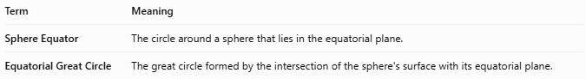
Term | Meaning
Sphere Equator | The circle around a sphere that lies in the equatorial plane.
Equatorial Great Circle | The great circle formed by the intersection of the sphere's surface with its equatorial plane.
Both refer to the circle whose plane passes through the sphere's center and is perpendicular to the chosen polar axis.

Comparison Table
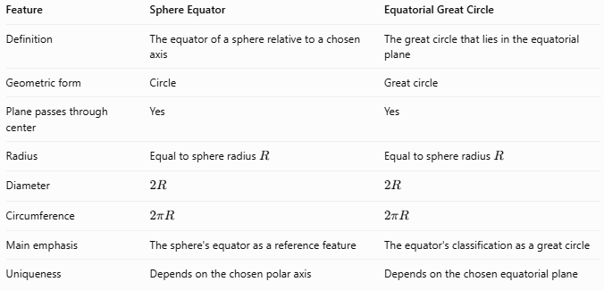
Feature | Sphere Equator | Equatorial Great Circle
Definition | The equator of a sphere relative to a chosen axis | The great circle that lies in the equatorial plane
Geometric form | Circle | Great circle
Plane passes through center | Yes | Yes
Radius | Equal to sphere radius $R$ | Equal to sphere radius $R$
Diameter | $$2R$$ | $$2R$$
Circumference | $$2πR$$ | $$2πR$$
Main emphasis | The sphere's equator as a reference feature | The equator's classification as a great circle
Uniqueness | Depends on the chosen polar axis | Depends on the chosen equatorial plane

Definitions
Sphere Equator
The sphere equator is the circular line on a sphere's surface halfway between two chosen poles, defined by an axis through the sphere's center.
Equatorial Great Circle
The equatorial great circle is the great circle formed where the equatorial plane intersects the sphere's surface. Its plane passes through the sphere's center and is perpendicular to the chosen polar axis.

Mathematical Relationship
For a sphere with radius $R$:
$$r_{e}=R$$
$$D_{e}=2R$$
$$C_{e}=2πR$$
Both terms describe the same circle when they refer to the same axis and equatorial plane.

Important Distinction
Not every great circle is an equator. A sphere has infinitely many great circles, but the equatorial great circle is the particular great circle selected by the chosen polar axis.

For example, Earth's equator is a great circle, while a meridian that passes through both geographic poles is also a great circle. They differ in orientation and geographical meaning.

Key distinction:
- Equator emphasizes the circle's role as the sphere's middle reference line.
- Equatorial Great Circle emphasizes its geometric classification as a great circle.

Applications
# Source: AI Source: Provided by: [Data Path: Persons Table -> ID Column: 1, Name_En Column: Motasem Essam] -> From: [ChatGPT] on [7/25/2026]
- Geography: Defines $0^{∘}$ latitude and separates Earth's hemispheres.
- Navigation: Provides a reference for measuring latitude and calculating routes.
- Astronomy: Helps describe the equatorial regions of planets and other rotating bodies.
- Geometry: Illustrates great circles, planes, radii, diameters, and hemispheres.
- Cartography: Serves as a reference line for coordinate systems and map projections.

Key Points
# Source: AI Source: Provided by: [Data Path: Persons Table -> ID Column: 1, Name_En Column: Motasem Essam] -> From: [ChatGPT] on [7/25/2026]
- The sphere equator is a great circle defined relative to a chosen polar axis.
- Its plane passes through the sphere's center.
- Its radius equals the sphere's radius.
- Its diameter equals the sphere's diameter.
- It divides the sphere into two equal hemispheres.
- Earth's geographic equator lies at $0^{∘}$ latitude.
- A perfect sphere has no uniquely determined equator until an axis or orientation is selected.

Conclusion
# Source: AI Source: Provided by: [Data Path: Persons Table -> ID Column: 1, Name_En Column: Motasem Essam] -> From: [ChatGPT] on [7/25/2026]
The sphere equator is the great circle around a sphere that lies in the plane through its center and perpendicular to a selected polar axis. It is important in solid geometry because it connects the concepts of great circles, diameters, radii, and hemispheres, and it provides a fundamental reference for Earth's geographic coordinate system.

